1. Tulis query untuk mendapatkan jumlah customer tiap bulan yang melakukan order pada tahun 1997.

select month(o.OrderDate) as Month, year(o.OrderDate) as Year, count(c.CustomerID) as TotalCustomerEveryMonth

from dbo.Customers c

left join dbo.Orders o on c.CustomerID=o.CustomerID

where year(o.OrderDate)='1997'

group by month(o.OrderDate), year(o.OrderDate)

Hasil

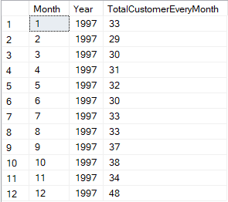

1. Tulis query untuk mendapatkan nama employee yang termasuk Sales Representative.

select FirstName+(' ')+LastName as EmployeeName, Title

from dbo.Employees

where Title='Sales Representative'

Hasil

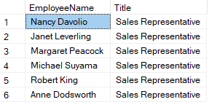

1. Tulis query untuk mendapatkan top 5 nama produk yang quantitynya paling banyak diorder pada bulan Januari 1997.

select top 5

p.ProductName, month(o.OrderDate) as Month, year(o.OrderDate) as Year, sum(od.Quantity) as TotalOrder

from dbo.Products p

left join dbo.[Order Details] od on p.ProductID=od.ProductID

left join dbo.Orders o on od.OrderID=o.OrderID

where month(o.OrderDate)='1' and year(o.OrderDate)='1997'

group by p.ProductName, month(o.OrderDate), year(o.OrderDate)

Hasil

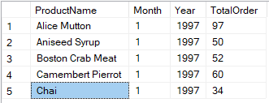

1. Tulis query untuk mendapatkan nama company yang melakukan order Chai pada bulan Juni 1997.

select c.CompanyName

from dbo.Customers c

left join dbo.Orders o on c.CustomerID=o.CustomerID

left join dbo.[Order Details] od on o.OrderID=od.OrderID

left join dbo.Products p on od.ProductID=p.ProductID

where p.ProductName='Chai' and year(o.OrderDate)='1997' and month(o.OrderDate)='6'

group by c.CompanyName

Hasil



1. Tulis query untuk mendapatkan jumlah OrderID yang pernah melakukan pembelian (unit_price dikali quantity) <=100, 100<x<=250, 250<x<=500, dan >500.

Jumlah OrderID <=100

select count (OrderID) as 'TotalBuy<=100'

from dbo.[Order Details]

where UnitPrice * Quantity<=100

hasil



Jumlah OrderID >500

select count (OrderID) as 'TotalBuy>500'

from dbo.[Order Details]

where UnitPrice * Quantity>500

hasil



100<=Jumlah OrderID <250

select count (OrderID) as '100<TotalBuy<=250'

from dbo.[Order Details]

where UnitPrice * Quantity>100

and UnitPrice * Quantity<=250

hasil



250<=Jumlah OrderID <500

select count (OrderID) as '250<TotalBuy<=500'

from dbo.[Order Details]

where UnitPrice * Quantity>250

and UnitPrice * Quantity<=500

hasil

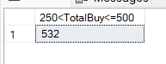

1. Tulis query untuk mendapatkan Company name pada tabel customer yang melakukan pembelian di atas 500 pada tahun 1997.

select c.CompanyName, sum(od.Quantity) as TotalOrder

from dbo.Customers c

left join dbo.Orders o on c.CustomerID=o.CustomerID

left join dbo.[Order Details] od on o.OrderID=od.OrderID

where year(o.OrderDate)='1997'

group by c.CompanyName

having sum(od.Quantity)> 500

order by sum(od.Quantity) desc

Hasil

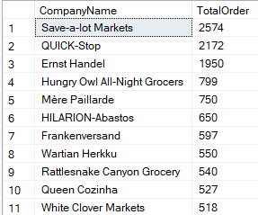

1. Tulis query untuk mendapatkan nama produk yang merupakan Top 5 sales tertinggi tiap bulan di tahun 1997.

select top 5

p.ProductName, sum(od.UnitPrice) * sum(od.Quantity) as TotalSales, month(o.OrderDate) as Month

from dbo.Products p

left join dbo.[Order Details] od on p.ProductID=od.ProductID

left join dbo.Orders o on od.OrderID=o.OrderID

where year(o.OrderDate)='1997'

group by p.ProductName, month(o.OrderDate)

order by sum(od.UnitPrice) * sum(od.Quantity) desc

hasil

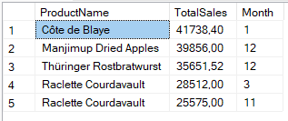

1. Buatlah view untuk melihat Order Details yang berisi OrderID, ProductID, ProductName, UnitPrice, Quantity, Discount, Harga setelah diskon.

create view v_OrderDetails

as

select

od.OrderID,

od.ProductID,

p.ProductName,

od.UnitPrice,

od.Quantity,

od.Discount,

od.UnitPrice - (od.Discount * od.UnitPrice) as FinalPrice

from dbo.[Order Details] od

left join dbo.Products p on od.ProductID=p.ProductID

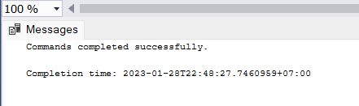

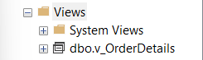

1. Buatlah procedure Invoice untuk memanggil CustomerID, CustomerName/company name, OrderID, OrderDate, RequiredDate, ShippedDate jika terdapat inputan CustomerID tertentu.

create procedure Customer @CustomerID varchar(30)

as

select

c.CustomerID,

c.CompanyName,

c.ContactName,

o.OrderID,

o.OrderDate,

o.RequiredDate,

o.ShippedDate

from dbo.Customers c

left join dbo.Orders o on c.CustomerID=o.CustomerID

where c.CustomerID = @CustomerID

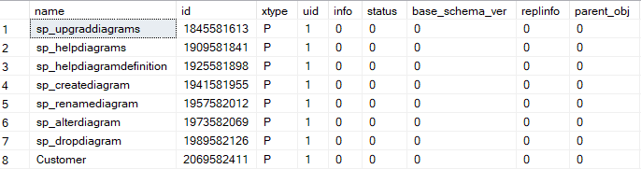

exec Customer @CustomerID = 'ALFKI'

